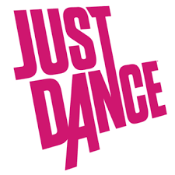
Just dance - YouTube povezave
Korona special, maj 2020
1. plesalec

Shawn Mendes ft. Camila Cabello: Señorita https://www.youtube.com/watch?v=s0fNRdQtY-A
Becky G ft. Bad Bunny: Mayores https://www.youtube.com/watch?v=pcIIz1nUAnc
Justin Bieber: Yummy https://www.youtube.com/watch?v=wjm6geLLs6s
Billie Eilish: Bad guy https://www.youtube.com/watch?v=5vXqZXLK3Ik
Ariana Grande: 7 Rings https://www.youtube.com/watch?v=JGai-vpWh2s
Marshmello & Anne Marie: Friends https://www.youtube.com/watch?v=EuqfelwcOHo
Shawn Mendes ft. Camila Cabello: Havana https://www.youtube.com/watch?v=N350RR6FQ_M
Dua Lipa: New Rules (https://www.youtube.com/watch?v=ZW1oVRsC3HU
Ava Max: Sweet But Psycho https://www.youtube.com/watch?v=teWy1xmhWmc
Selena Gomez, Marshmello: Wolves https://www.youtube.com/watch?v=02ixqN5AM4M
DJ Snake, Selena Gomez, Cardi B: Taki Taki https://www.youtube.com/watch?v=mA9Gv8dSkAQ
Ariana Grande: No Tears Left To Cry https://www.youtube.com/watch?v=BaV46rVb3Lw
Pedro Capó: Calma https://www.youtube.com/watch?v=IJW_0sgawAs
Taylor Swift: Look What You Made Me Do https://www.youtube.com/watch?v=imcfmPGZ-rg
Pitbull & J Balvin Ft. Camila Cabello: Hey Ma https://www.youtube.com/watch?v=PcgrBa70jlU
Avicii: Wake me up https://www.youtube.com/watch?v=F0-fZ75SYRo
Ed Sheeran: Shape Of You https://www.youtube.com/watch?v=zAgUrkk-srI
Post Malone & Swae Lee: Sunflower https://www.youtube.com/watch?v=ByR75vokUUs
LMFAO ft Lauren Bennett: Party Rock Anthem - https://www.youtube.com/watch?v=6h5LieoWoa4
Camilla Cabello: My Oh My - https://www.youtube.com/watch?v=TDOoMfsMk2g
Rihanna: Where Have You Been https://www.youtube.com/watch?v=jiLUvXUJa48
Pharrell Williams: Happy: https://www.youtube.com/watch?v=G74_o_43_RQ
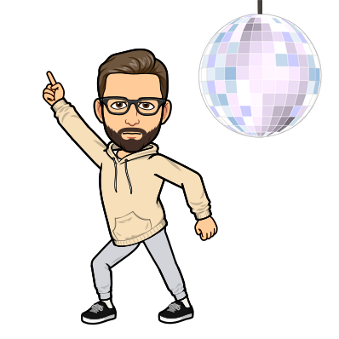
Izbral: Mladen Kopasić

